Objective detection performance analysis based on image defusing

1. Introduction
This project aims to study whether the image deblurring under the motion blur scene can improve the downstream target detection performance. The job requirements not only focus on image recovery itself, but also require image recovery, target detection, data set construction and model micro-adjustment into a complete process and analyse the impact of recovery steps on subsequent visual understanding tasks.
This experiment uses pairs of fuzzy images and clear images for analysis. The overall process is divided into four stages. First, the traditional image recovery method is used to process the blurred image, and the recovery quality is evaluated using indicators such as MSE, PSNR and SSIM. Secondly, use pre-training YOLOv8n to detect blurry images and recovery images respectively, and compare the number of detection boxes, average confidence and typical failure cases. Thirdly, build a data set of the three domains of blur, deblur and sharp from the sample, and generate labels that can be used for training. Finally, fine-tune YOLOv8n on the deblur domain and compare the performance of the model in three test domains to analyse the relationship between recovery and detection.

2. Version control, reproduction and AI use
According to the job requirements, the project needs to be version managed through Git, and keep the experimental process, key results and AI usage records to ensure that the experiment is traceable and reprodible. The current project has established a GitHub repository and saved notebooks, processed data sets, training outputs, README and AI logs, which is consistent with the instructions in the original report.
In terms of AI use, the AI tools in this project are mainly used to assist in understanding job requirements, plan project structure, organise README and polish illustrative text, rather than replacing the experiment itself. All experimental codes, parameter settings and result interpretations need to be combined with notebook output for manual inspection. On the one hand, this can improve efficiency, and on the other hand, it can also avoid directly treating AI-generated content as reliable experimental conclusions, to meet academic norms and ethical requirements.

3. Methodology

3.1 Image deblurring
This project uses two traditional methods as the baseline: Unsharp Masking and Wiener Filter. The reason for choosing these two methods is that they are simple to implement and explainable, and are suitable as representatives of classical recovery methods to observe whether "simple image enhancement" will help subsequent target detection. Unsharp Masking is essentially closer to sharpening, improving visual clarity by enhancing the edge; Wiener Filter tries to restore under the premise of a given degradation model and noise assumption.

3.2 Target detection and analysis
Without any retraining, the project uses pre-trained YOLOv8n to infer blur images and deblur images to compare their average number of detections and average confidence. The purpose of this step is not to test the final performance after training, but to observe alone whether the "recovery operation itself" can directly help the detector better identify the target.

3.3 Dataset Construction and Model Training
In the training stage, the project selects 200 pairs of images from the original sample and divides them into three subsets: train, validation and test, with a ratio of 140/30/30. After that, synchronise the generated tags into the three domains of blur, deblur and sharp to ensure that the same set of target annotations is used under the three image conditions. Finally, the YOLOv8n pre-training weight is used as initialisation to fine-tune 10 epochs on the deblur data. The training parameters include imgsz=640 and batch=8. The goal of this design is to test whether the detector can achieve better detection results than directly using the pre-trained model if it is specially adapted to the restored image domain.

4. Experimental results and analysis

4.1 Deblurring Quality Evaluation
Judging from the results of batch evaluation, neither traditional recovery method is better than the original blur image. The average MSE of the Blur baseline is 481.94, the average PSNR is 22.61, and the average SSIM is 0.6048; the average MSE of Unsharp Masking rises to 506.60, the average PSNR decreases to 22.40, and the average SSIM decreases to 0.5999; the result of Wiener Filter is the worst, with an average MSE as high as 1679.02, the average PSNR is only 17.37, and the average SSIM is only 0.3209.
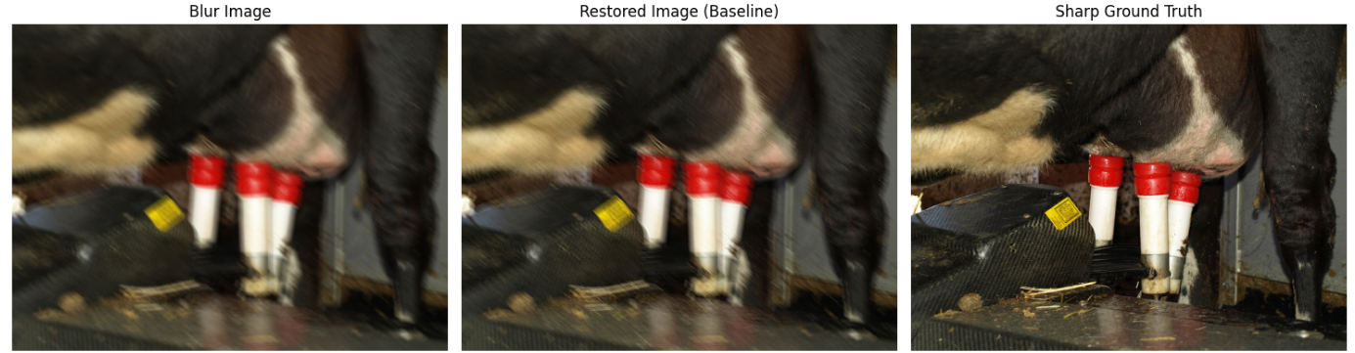 Fig1

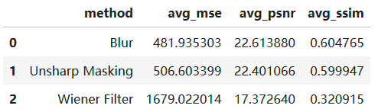
Fig2
These results show that for real and complex motion blurs, simple traditional recovery methods are difficult to effectively reconstruct the destroyed high-frequency details. Although Unsharp Masking can visually enhance the edge, it is more like a sharpening operation than a real recovery of the fuzzy degradation process, so the average index is slightly worse. Wiener Filter relies on fixed fuzzy kernel and noise assumptions, which often does not match the actual degradation in real scenarios, so its performance is significantly worse. On the whole, this part of the result supports an important judgement: the simple classical recovery method is not enough to effectively solve the problem of motion blur in this task.

4.2 Performance of pre-trained detectors on blur and deblur
To analyse whether simple defusing can directly improve the target detection performance, this experiment uses pre-trained YOLOv8n to infer the blur image and the deblur image processed by Unsharp Masking respectively and compare the average number of detections and the average confidence. The results show that de-fuzzying does not bring about performance improvement. On the contrary, the average number of detections of the model on the blur image is 1.35, while the deblur image drops to 1.20; the average confidence also drops from 0.307 to 0.289.
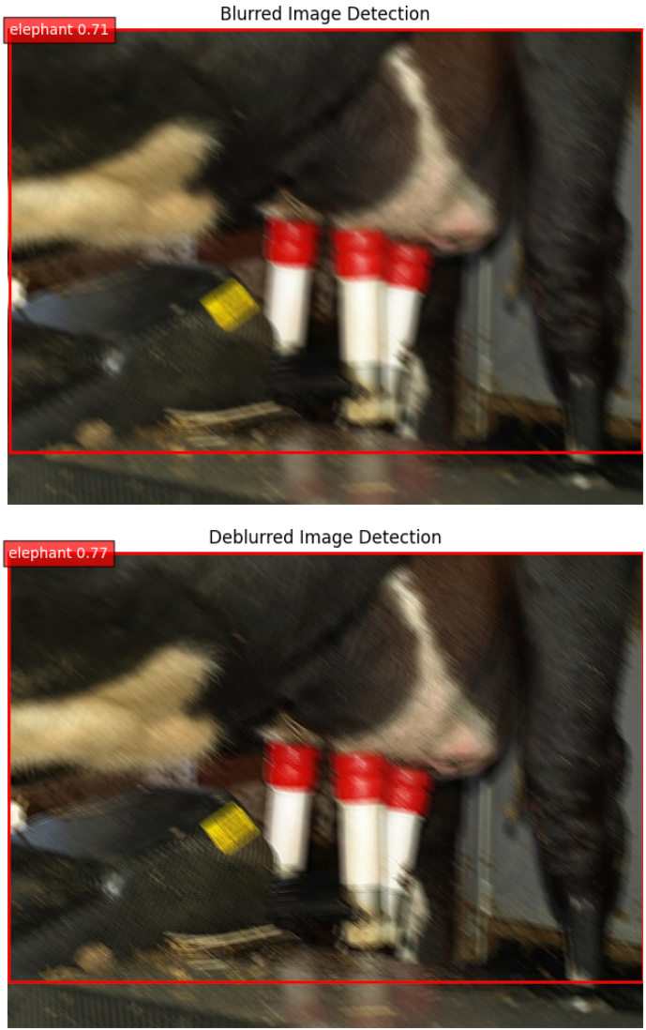
Fig3
Fig4
This result shows that simple Unsharp Masking cannot stably improve the recognition effect of pre-trained detectors on blurry images. Although the method can visually enhance the edge, it is inherently closer to sharpening than restoring the structural information lost due to motion blur. During the processing process, edge enhancement may also amplify noise, artefacts or local texture distortion, thus interfering with the detector's judgement of target characteristics.
Therefore, this experiment shows that using the traditional sharpened recovery method directly as the target detection pre-treatment does not guarantee the improvement of the detection performance. For downstream detection tasks, the visual "clearer" appearance of the image does not necessarily mean that the model can recognise the target more accurately. This also further shows that in this task, the effect of simply relying on simple recovery methods is limited. A more effective practice may be to adopt a stronger de-fuzzing model, or to adapt the detector to the restored image domain through subsequent fine-tuning.

4.3 Cross-domain comparison of fine-tuning models
In order to further analyse the impact of recovery domain training on detection performance, this experiment evaluated the three test domains of blur, deblur and sharp respectively after completing the YOLOv8n fine-tuning on the deblur data. The results show that on the blur test set, the model's Precision is 0.436, Recall is 0.321, mAP50 is 0.317, and mAP50-95 is 0.188; on the deblur test set, Precision is 0.451, Recall is 0.347, mAP50 is 0.393, and mAP50-95 is 0.235; on the sharp test set, all four indicators are the highest, 0.653, 0.418, 0.516 and 0.371 respectively.
Judging from the overall performance, the fine-tuned model achieved the best detection results in the sharp domain, ranked second in the deblur domain, and the worst in the blur domain. This shows that compared with the original blurred image, the restored image can indeed provide more useful information for the detection task, thus bringing about a certain degree of performance improvement. However, the result on the deblur image is still significantly lower than that of the sharp image, indicating that simple recovery cannot fully compensate for the loss of information caused by motion blur.
This part of the result has two implications. First of all, it shows that there is a clear relationship between image quality and target detection performance. The closer the image is to the original clarity domain, the better the detection effect is usually. Secondly, it also shows that although the restored image is not necessarily significantly better than the fuzzy image in terms of pixel-level indicators, it can still help the detector better adapt to the image domain after proper training. Therefore, recovery domain training has practical value in improving the detection ability under fuzzy scenarios.
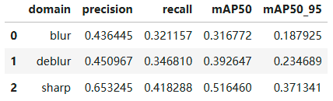
Fig5
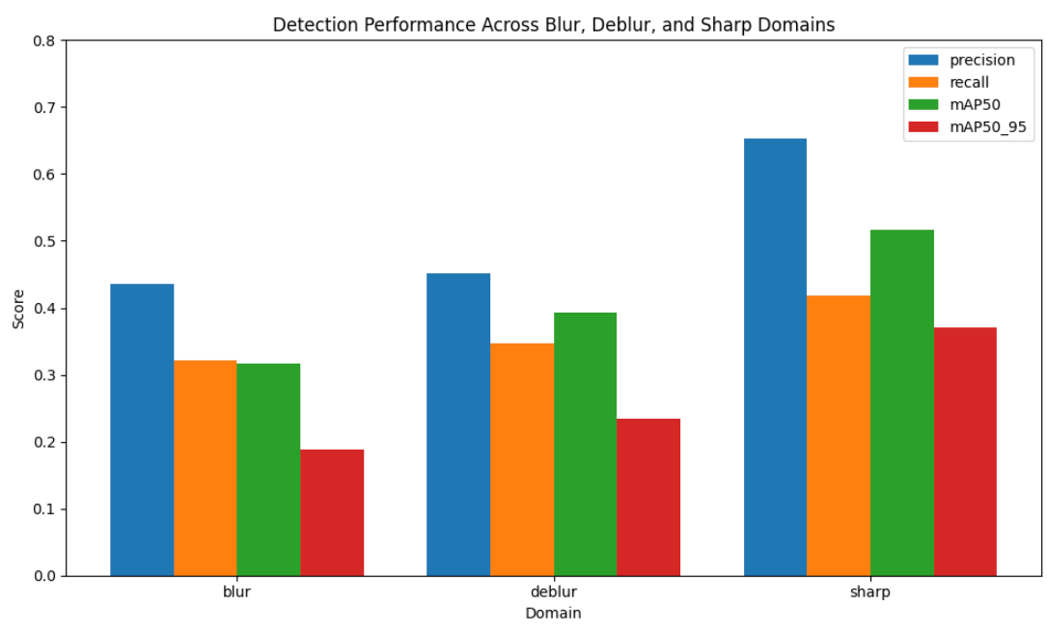
Fig6
This result shows that after restored-domain training, the model has the best overall performance in the deblur domain, especially the precision and mAP indicators, while the sharp domain has a slight advantage in recall. This shows that restored image training does help the detector adapt to the image distribution after blurring, but "visually clearer" does not mean that all indicators will be optimal at the same time.

4.4 Comparison between Pretrained and Fine-tuned
In order to verify whether fine-tuning is more effective than simple image preprocessing, this experiment further compares the performance of pre-trained YOLOv8n and fine-tuned YOLOv8n on the deblur test set. The results show that the Precision, Recall, mAP50 and mAP50-95 of the pre-training model are 0.680, 0.190, 0.221 and 0.138 respectively; while the corresponding results of the fine-tuned model are 0.451, 0.347, 0.393 and 0.235.
It can be seen that the fine-tuned model has been significantly improved in the three indicators of Recall, mAP50 and mAP50-95. Among them, Recall was increased from 0.190 to 0.347, indicating that the model can detect more real targets; mAP50 was increased from 0.221 to 0.393, and mAP50-95 was increased from 0.138 to 0.235, indicating that the overall detection quality of the model has been significantly improved. However, the Precision dropped from 0.680 to 0.451, indicating that the model detected more targets and also brought more mischecks.
This result shows that the fine-tuned model is more adapted to the distribution characteristics of the deblur image domain, so that it can find the target more actively, but at the cost, the prediction results become more radical and false alarms increase. Nevertheless, judging from the comprehensive indicators, the overall benefit brought by fine-tuning is still significantly greater than the direct use of the pre-training model. This also shows that in this experiment, model adaptation for the recovery domain is more effective than simply relying on traditional deblurring as pre-test processing.
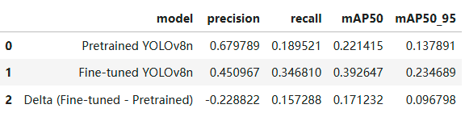
Fig7

5. Critical discussion
Combining the experimental results of this project, it can be found that there is a relationship between image recovery quality and target detection performance, but the two are not completely equivalent. In the previous deblurring quality evaluation, Unsharp Masking was not superior to the original blur image in MSE, PSNR and SSIM; in the pre-training detection experiment, the direct simple sharpening of the blur image did not bring about an improvement in detection performance, and the average number of detections and average confidence decreased slightly. This shows that for complex motion blurs, it is difficult to significantly improve the image quality or stably improve the downstream detection performance by relying solely on simple traditional recovery methods.
However, on the other hand, the results of cross-domain evaluation and model comparison show that the deblur domain is not completely worthless. Although the recovered image is not ideal in terms of pixel-level indicators, Recall, mAP50 and mAP50-95 have all been significantly improved after the detector completes fine-tuning on the image domain. This shows that what the target detection model really relies on is not only the overall pixel similarity, but also whether the structural information that is conducive to target identification and positioning is retained. In other words, even if the recovery method itself is weak, as long as the training process can adapt the model to the statistical distribution of the recovery domain, the detection performance may still be improved.
Of course, there are still obvious limitations in this project. First of all, the experiment only uses Unsharp Masking and Wiener Filter as the recovery baseline. These two methods are relatively traditional image processing methods, and it is difficult to deal with complex and diverse motion blurs in real scenes. Secondly, the training data is relatively small, only 200 pairs of images are used, and the number of training rounds is only 10 epoch, so the model performance has not been fully exploited. Thirdly, the label is generated synchronously through the existing annotation, instead of re-manual fine labelling, which may cause certain annotation errors to be inherited in the training and evaluation process. Finally, this experiment uses the lightweight model of YOLOv8n, which is easier to run under the premise of limited computing resources, but its performance limit is also relatively limited.
Therefore, this project is more suitable as a complete process verification: it shows the complete experimental chain from image recovery, detection and analysis, data preparation to model fine-tuning, and also proves that the idea of "recovery domain adaptation" has a certain feasibility. However, if you want to further improve the detection performance, you still need to try stronger deep learning to blur the model, larger-scale data sets and more complete training strategies.

6. Conclusion

In general, this project explains that the traditional deblurring method has limited recovery ability to complex motion blur images, and the improvement of target detection is also relatively limited when it is simply used as a preprocessing step. However, after fine-tuning the detector on the restored domain, the model performance can be significantly improved, especially the precision and mAP on the deblur test set. Therefore, this project supports the conclusion that for target detection tasks in fuzzy scenarios, training and adaptation for the target domain is more effective than relying solely on simple image enhancement. In the future, we can further try stronger de-fuzzy models, larger-scale data sets and manual verification labels to obtain more stable and generalized results.

